**CRM APPPLICATION THAT HELPS TO BOOK A VISA SLOT**

1. **INTRODUCTION**
   1. **Overview**

CRM project management is **a solution that combines CRM (Customer Relationship Management**) software and project management tools to serve customers and keep them satisfied[**1**](https://www.bing.com/ck/a?!&&p=fb508ab9a63c7149JmltdHM9MTY4MTg2MjQwMCZpZ3VpZD0zMTk1YTJiYS1iMWNiLTYxM2UtMjBkZS1hY2JjYjA3NDYwNTAmaW5zaWQ9NTQ0MA&ptn=3&hsh=3&fclid=3195a2ba-b1cb-613e-20de-acbcb0746050&u=a1aHR0cHM6Ly9wcm9qZWN0LW1hbmFnZW1lbnQuY29tL2NybS1wcm9qZWN0LW1hbmFnZW1lbnQv&ntb=1). CRM software helps to manage customer information and details[**2**](https://www.bing.com/ck/a?!&&p=d92348ebcb3203b4JmltdHM9MTY4MTg2MjQwMCZpZ3VpZD0zMTk1YTJiYS1iMWNiLTYxM2UtMjBkZS1hY2JjYjA3NDYwNTAmaW5zaWQ9NTQ0MQ&ptn=3&hsh=3&fclid=3195a2ba-b1cb-613e-20de-acbcb0746050&u=a1aHR0cHM6Ly9jcm0ud2Fsa21lLmNvbS9hbGwtYWJvdXQtY3JtLXByb2plY3QtbWFuYWdlbWVudC8&ntb=1), while project management tools help to define tasks, identify resources, and track efforts[**1**](https://www.bing.com/ck/a?!&&p=4b667ceb81bce1a6JmltdHM9MTY4MTg2MjQwMCZpZ3VpZD0zMTk1YTJiYS1iMWNiLTYxM2UtMjBkZS1hY2JjYjA3NDYwNTAmaW5zaWQ9NTQ0Mg&ptn=3&hsh=3&fclid=3195a2ba-b1cb-613e-20de-acbcb0746050&u=a1aHR0cHM6Ly9wcm9qZWN0LW1hbmFnZW1lbnQuY29tL2NybS1wcm9qZWN0LW1hbmFnZW1lbnQv&ntb=1). CRM project management can help to improve customer feedback, communication, and retention[**3**](https://www.bing.com/ck/a?!&&p=2cd4cc8a79f8b893JmltdHM9MTY4MTg2MjQwMCZpZ3VpZD0zMTk1YTJiYS1iMWNiLTYxM2UtMjBkZS1hY2JjYjA3NDYwNTAmaW5zaWQ9NTQ0Mw&ptn=3&hsh=3&fclid=3195a2ba-b1cb-613e-20de-acbcb0746050&u=a1aHR0cHM6Ly9jbGlja3VwLmNvbS9ibG9nL2NybS1hbmQtcHJvamVjdC1tYW5hZ2VtZW50Lw&ntb=1). CRM project management also involves the process of implementing a new CRM system, which can take about two years for a large enterprise and impact the revenue and productivity of the organization[**4**](https://www.bing.com/ck/a?!&&p=e189069fbbc41707JmltdHM9MTY4MTg2MjQwMCZpZ3VpZD0zMTk1YTJiYS1iMWNiLTYxM2UtMjBkZS1hY2JjYjA3NDYwNTAmaW5zaWQ9NTQ0NA&ptn=3&hsh=3&fclid=3195a2ba-b1cb-613e-20de-acbcb0746050&u=a1aHR0cHM6Ly9jcm0ud2Fsa21lLmNvbS93aGF0LWlzLWNybS1wcm9qZWN0LW1hbmFnZW1lbnQv&ntb=1). Therefore, CRM project management requires a proper CRM implementation plan that can save time, choose the right CRM platform, and make the most of the CRM data[**5**](https://www.bing.com/ck/a?!&&p=02e96f8f0b9a25d1JmltdHM9MTY4MTg2MjQwMCZpZ3VpZD0zMTk1YTJiYS1iMWNiLTYxM2UtMjBkZS1hY2JjYjA3NDYwNTAmaW5zaWQ9NTQ0NQ&ptn=3&hsh=3&fclid=3195a2ba-b1cb-613e-20de-acbcb0746050&u=a1aHR0cHM6Ly9jcm0ub3JnL2NybWxhbmQvY3JtLWltcGxlbWVudGF0aW9u&ntb=1).

**1.2 Purpose**

**The use of this project ?**

The project management system built on a CRM platform allows team to easily understand tasks and projects that realte to cultivating the customer relationship**.**

**What can be achieved using this?**

**CRM** benefits include a centralized communication channel, increased customer retention, detailed insights & analytics, a better customer support system.

**2 PROBLEM DEFINITION & DESIGN THINKING**

**2.1 Empathy Map**

# 

**2.2 Ideation & Brainstroming**

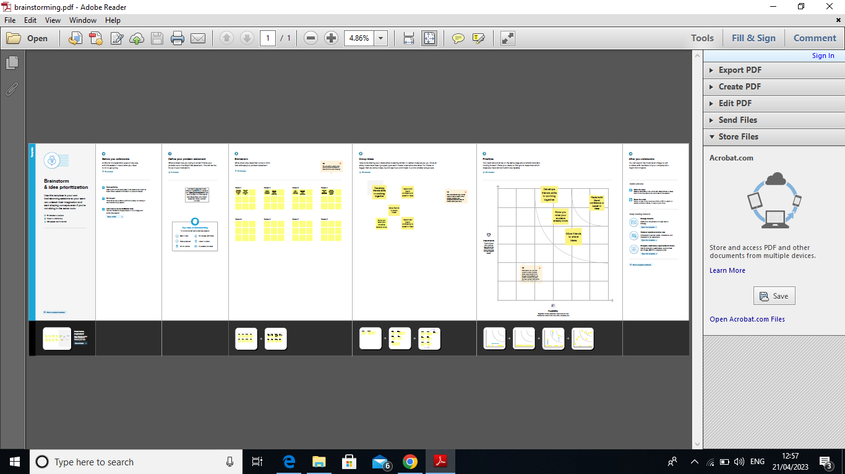

**3 RESULT**

**3.1 Data model :**

|  |  |
| --- | --- |
| **Object**  **Name** | **Field in the object** |
| **Obj 1** | |  |  | | --- | --- | | Field label | Data type | |  |  | |  |  | |
| **Obj 2** | |  |  | | --- | --- | | Field label | Data type | |  |  | |  |  | |

**Activity & Screeenshot**

**Activity-1:**

**Creation of custom object : Passport**

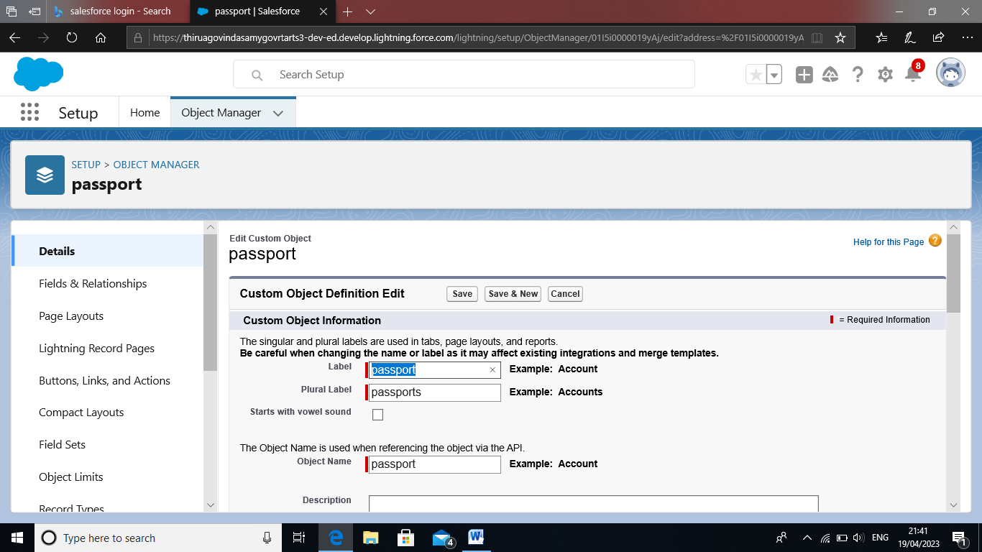

**Activity-2:**

**Creation of field on custom : Passport**

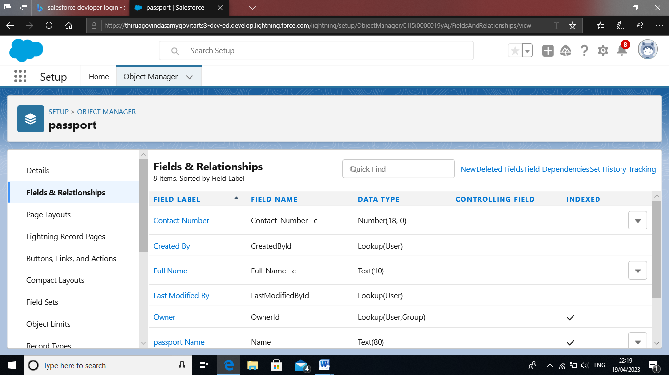

**Activity-2**

**Creation of relationship :**

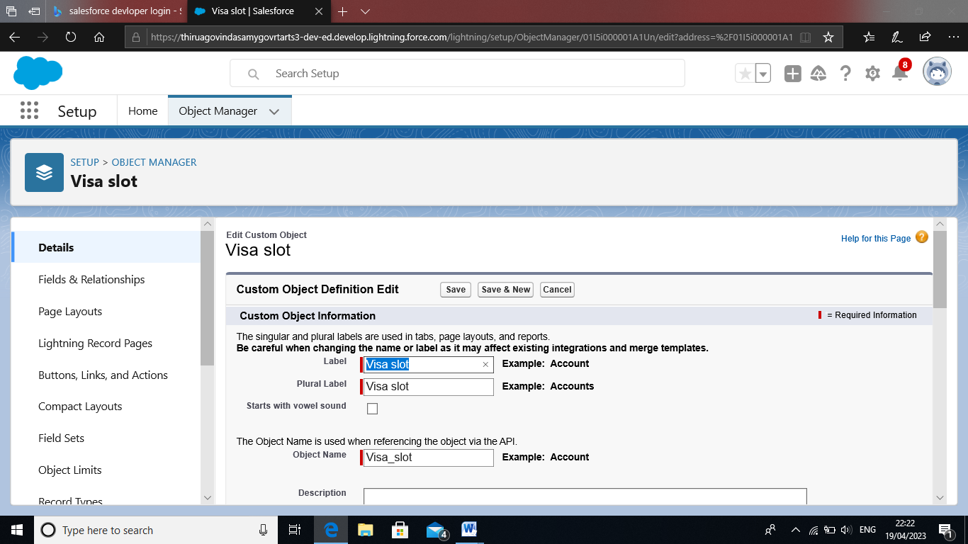

**Activity**

**Creation of app :**

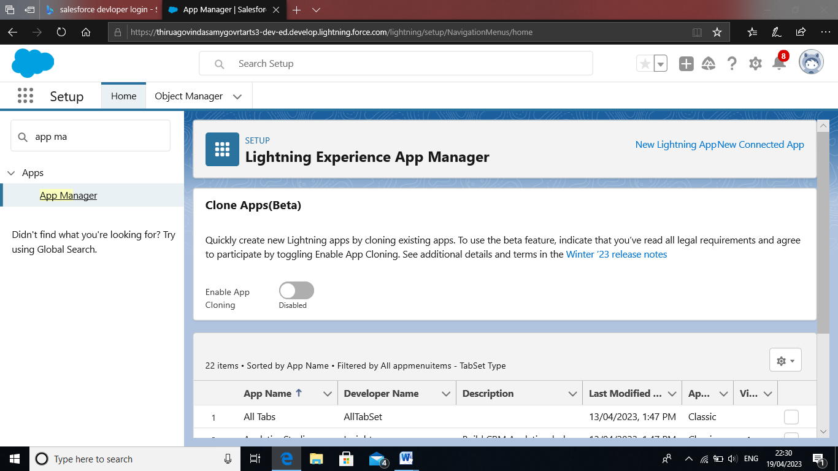

**Activity-1**

**Creation of user :**

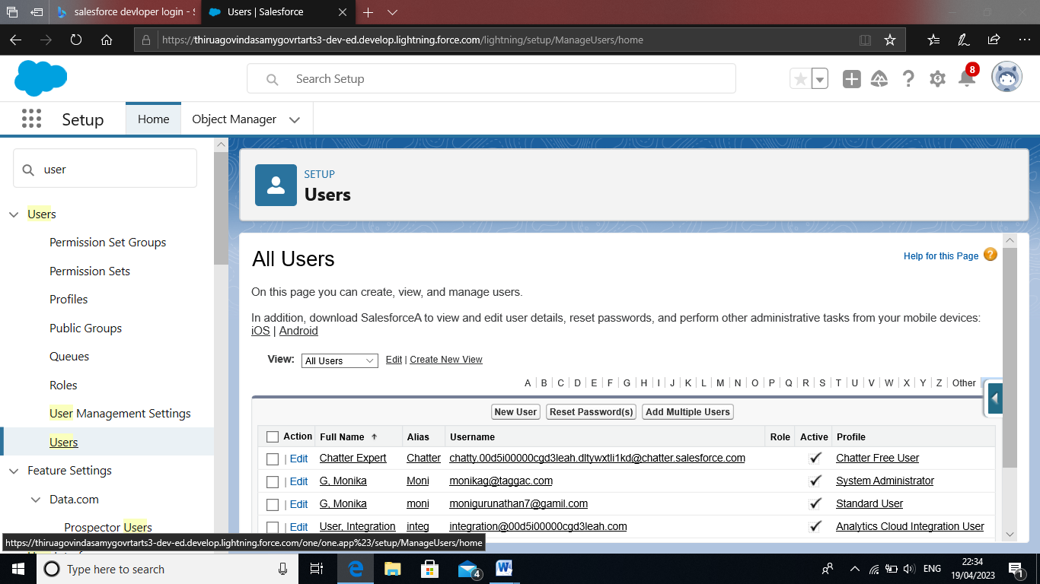

**Activity-2 :**

**OWD- Organization wide defult settings**

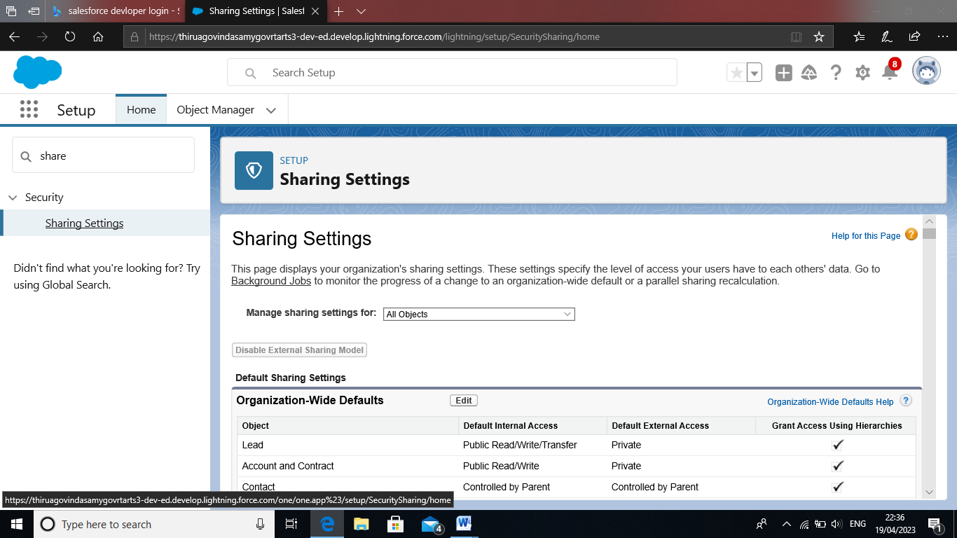

**Activity-1 :**

**Creation of report :**

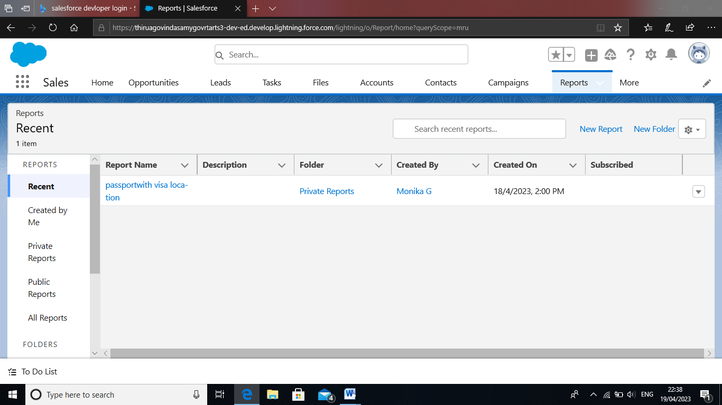

**Activity**

**Creation of dashboard :**

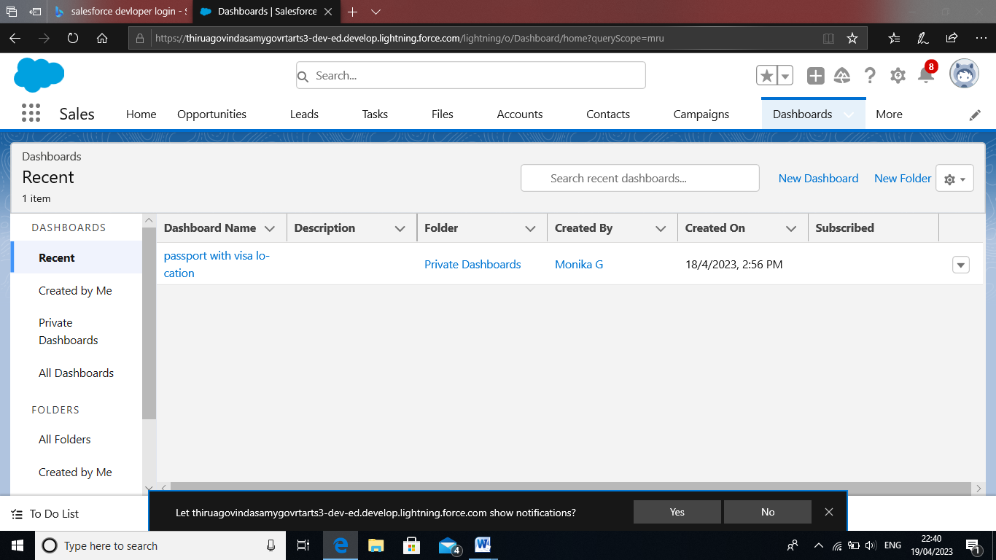

**4 Trailhead profile Public URL :**

**Team Lead –https://trabilblazer.me/id/dkrishnan47**

**Team Member 1 –https://trailblazer.me/id/trajesh22**

**Team Member 2 –https://trabilblazer./id/kkayal6**

**Team Member 3 –https://trailblazer.me/id/gayathri1504**

**5 ADVANTAGE & DISAVANTAGE**

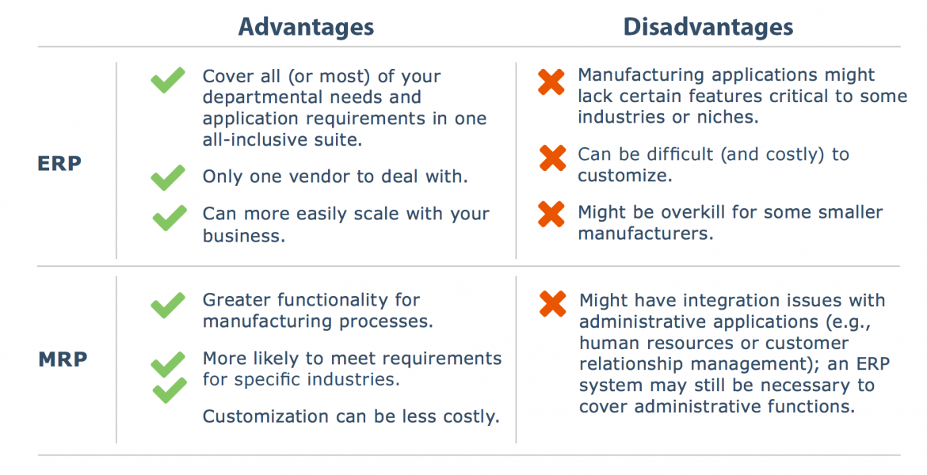

**6 APPLICATION**

Applications of a CRM

[Application 1: Tracking Customers](https://evolvedmetrics.com/applications-of-crm/#application-1-tracking-customers)

[Application 2: Collecting Data for Marketing](https://evolvedmetrics.com/applications-of-crm/#application-2-collecting-data-for-marketing)

[Application 3: Improving Interactions and Communications](https://evolvedmetrics.com/applications-of-crm/#application-3-improving-interactions-and-communications)

[Application 4: Streamlining Internal Sales Processes](https://evolvedmetrics.com/applications-of-crm/#application-4-streamlining-internal-sales-processes)

[Application 5: Planning Your Operations.](https://evolvedmetrics.com/applications-of-crm/#application-5-planning-your-operations)

**7 CONCLUSION**

* **CRM is a concept, implemented with the support of various technologies.**
* **Supporting technologies include data warehousing, data mining , OLAP etc.**
* **A proper Data Warehousing should be in place for any CRM initiative.**
* **Customer needs should be in focus while implementing CRM.**

**8 FUTURE SCOPE**

**CRM** is predicted to become more powerful to support customer first, not company first businesses. Bringing together disparate teams, data, and system integrations, the **CRM** of the **future** is set to be centralized and empowered by AI and mobile capabilities.